CIS-40A Lab 6-1: TCP/IP Utilities in Windows.
All Answers were before connecting to network. Some additions were made afterwards

In this exercise, we will be using command prompt in Windows OS to troubleshoot networking. Complete the below procedures, answer the lab questions and provide necessary screen capture.
If you are working remotely, you can use your Windows PC or Windows Server VM that was provided in Lab 4.

ARP
Address Resolution Protocol (ARP) is a protocol or procedure that connects an ever-changing Internet Protocol (IP) address to a fixed physical machine address, also known as a media access control (MAC) address, in a local-area network (LAN). This mapping procedure is important because the lengths of the IP and MAC addresses differ, and a translation is needed so that the systems can recognize one another. The most used IP today is IP version 4 (IPv4). An IP address is 32 bits long. However, MAC addresses are 48 bits long. ARP translates the 32-bit address to 48 and vice versa.
Types of ARP:
- Proxy ARP is a technique by which a proxy device on a given network answers the ARP request for an IP address that is not on that network. The proxy is aware of the location of the traffic's destination and offers its own MAC address as the destination.
- Gratuitous ARP is almost like an administrative procedure, carried out as a way for a host on a network to simply announce or update its IP-to-MAC address. Gratuitous ARP is not prompted by an ARP request to translate an IP address to a MAC address.
- Reverse ARP (RARP): Host machines that do not know their own IP address can use the Reverse Address Resolution Protocol (RARP) for discovery.
- Inverse ARP (IARP): Whereas ARP uses an IP address to find a MAC address, IARP uses a MAC address to find an IP address.
ARP is necessary because the software address (IP address) of the host or computer connected to the network needs to be translated to a hardware address (MAC address). Without ARP, a host would not be able to figure out the hardware address of another host. The LAN keeps a table or directory that maps IP addresses to MAC addresses of the different devices, including both endpoints and routers on that network.
This table or directory is not maintained by users or even by IT administrators. Instead, the ARP protocol creates entries on the fly. If a user's device does not know the hardware address of the destination host, the device will send a message to every host on the network asking for this address. When the proper destination host learns of the request, it will reply with its hardware address, which will then be stored in the ARP directory or table.

Load VM in VirtualBox
- Connect External USB drive and copy-paste CIS40AWindows10VM folder to the computer desktop.
- In Windows Search bar, searching for “VirtualBox” in Windows search bar, then open the app.
- On Virtualbox app, click Add (+) button on VirtualBox app.
- Browse to the Desktop and locate CIS40AWindows10VMCIS40AWindows10VM.vdi file (blue icon)
- Once the CIS40AWindows10VM is added to the VirtualBox, click Start.
- Login
  - Username: CIS40AStudent
  - Password: CIS40A!

Use Utilities in Windows
- On Windows search bar, enter “cmd” and right-click Command Prompt and choose Run As Administrator.
- Open command prompt and enter command: arp -a
This command displays the arp cache entry for a specific IP address.
- How many interface addresses are shown? 5

- In command prompt, enter command: arp -d
This command flushes the arp cache entry.

- In command prompt, enter command: arp -g
- Is the output the same as #3? no, there is now 2

- Repeat step 2 to verify that the arp cache is cleared.
- Did the cache clear? it has the same addresses as #4

- To manually add entries into ARP cache use command: arp -s <IPADDRESS> <MACADDRESS>
IP address: 172.49.0.100
Mac address: 08-00-27-31-3D-00
Enter your IP address and MAC address.
- Were you able to enter the static cache? yes
- Take a screen capture for lab submission
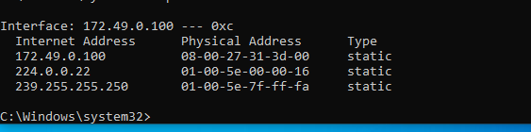

- In command prompt, use command: hostname
- Record the system name. DESKTOP-7NGB8T5

- In command prompt, use command: pathping 127.0.0.1
The PathPing command followed by a host name initiates what looks like a somewhat standard Tracert process. Once this process completes however, the tool takes 300 seconds (five minutes) to gather statistics, and then reports latency and packet loss statistics that are more detailed than those provided by Ping or Tracert.
- How many hops were shown? 1, but technically 0 since it didn’t go anywhere
- Does the output contain your system name from #7? Yes

- In command prompt, use command: nbtstat -r
This command shows how many NetBIOS names the device has been able to resolve recently.
- What is the percentage of Registered by Broadcast? 100% (3)
- What is the percentage of Registered by Name Server? 0% (0)

- Next, we will use PowerShell to obtain ARP information. Search for PowerShell on Windows search bar. Right-click PowerShell app and choose Run As Administrator and enter command: Get-NetNeighbor
The New-NetNeighbor cmdlet creates a neighbor cache entry. The neighbor cache maintains information for each on-link neighbor, including the IP address and the associated link-layer address. The address family that you specify for the neighbor cache entry must match the address family of the IP interface.
- Take a screen capture.
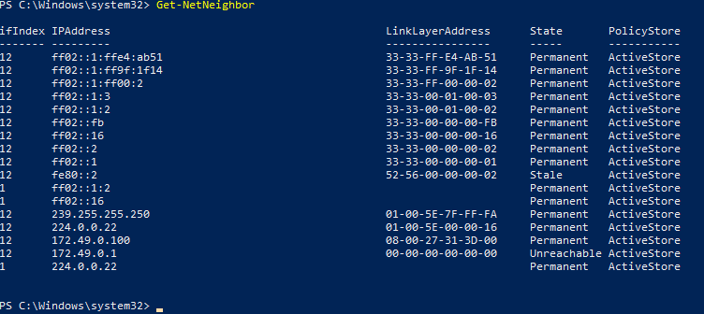
- How many address entries are stale? 1 Ureachable? 1

- In PowerShell, enter command: Get-NetNeighbor | Format-List -Property *
This command gets all the neighbor cache entries. The command uses the Format-List cmdlet to display all the properties in the output in the form of a table. For more information, type Get-Help Format-Table.
- How is the output different from the previous command? It lists A LOT more additional information, such as Description, Name, and a lot more. Format lets us list out each connection.

- In PowerShell, enter command: Get-NetNeighbor -AddressFamily IPv6
This command gets information about the neighbor cache for neighbors that have an IPv6 address.
- What are the suffixes of these addresses ff02, and ff80

- In PowerShell, enter command: Get-NetNeighbor -State Reachable | Get-NetAdapter
This command gets a NetNeighbor object that contains neighbor cache entries that are reachable. The command passes the NetNeighbor object to the Get-NetAdapter cmdlet by using the pipeline operator. The Get-NetAdapter cmdlet gets the network adapters that have the interface index number for the network neighbors stored the NetNeighbor object.
- How many entries are displayed? I have an error, so I assume 0.

Note: Depending on the cached state. Only filter state that is listed. Error will occur if the list does not contain the specified state, such as “Reachable”

TCP and UDP Connections
The Transmission Control Protocol (TCP) provides reliable, ordered, and error-checked delivery of a stream of octets (bytes) between applications running on hosts communicating via an IP network. Major internet applications such as the World Wide Web, email, remote administration, and file transfer rely on TCP, which is part of the Transport Layer of the TCP/IP suite. SSL/TLS often runs on top of TCP. TCP is connection-oriented, and a connection between client and server is established before data can be sent. The server must be listening (passive open) for connection requests from clients before a connection is established. Three-way handshake (active open), retransmission, and error-detection adds to reliability but lengthens latency. Applications that do not require reliable data stream service may use the User Datagram Protocol (UDP), which provides a connectionless datagram service that prioritizes time over reliability. TCP employs network congestion avoidance. However, there are vulnerabilities to TCP including denial of service, connection hijacking, TCP veto, and reset attack.
User datagram protocol (UDP) operates on top of the Internet Protocol (IP) to transmit datagrams over a network. UDP does not require the source and destination to establish a three-way handshake before transmission takes place. Additionally, there is no need for an end-to-end connection. Since UDP avoids the overhead associated with connections, error checks and the retransmission of missing data, it’s suitable for real-time or high-performance applications that don’t require data verification or correction. If verification is needed, it can be performed at the application layer. UDP is commonly used for Remote Procedure Call (RPC) applications, although RPC can also work top of TCP. RPC applications need to be aware they are running on UDP and must then implement their own reliability mechanisms. UDP has the following benefits:
- No retransmission delays – UDP is suitable for time-sensitive applications that can’t afford retransmission delays for dropped packets. Examples include Voice over IP (VoIP), online games, and media streaming.
- Speed – UDP’s speed makes it useful for query-response protocols such as DNS, in which data packets are small and transactional.
- Suitable for broadcasts – UDP’s lack of end-to-end communication makes it suitable for broadcasts, in which transmitted data packets are addressed as receivable by all devices on the internet. UDP broadcasts can be received by large numbers of clients without server-side overhead.
UDP’s lack of a verification mechanism and end-to-end connections makes it vulnerable to several DDoS attacks, such as UDP flood, DNS amplification and port scan. Attackers can spoof packets with arbitrary IP addresses and reach the application directly with those packets.
- In PowerShell, enter command: Get-NetTCPConnection
This command gets all current TCP connections.
- How many entries have the CloseWait state? 0, all of mine are in Listen (once on internet, I have 1)
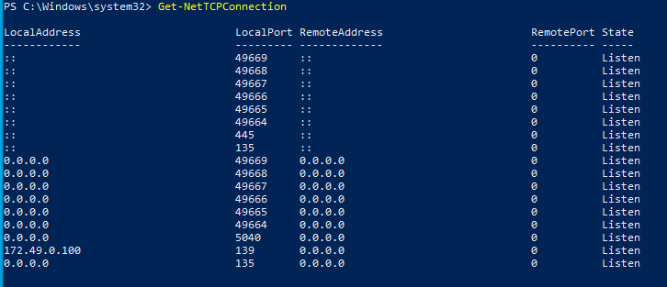

- In PowerShell, enter command: Get-NetTCPConnection -State Established
This command gets all TCP connections that have an Established state.
- Compared to previous step, are there less entries listed? Yes, as none are in Established state (Once on internet, there are some, but it is less)

- In PowerShell, enter command: Get-NetTCPConnection -AppliedSetting Internet
This command gets all TCP connections that use a TCP applied setting of Internet.
- What are remote ports listed? 0. I am getting the no objects found error
- Write down 3 commonly listed Owning Process values 652, 2504, and 1144

- In PowerShell, enter command: SKIP THIS STEP!!!
Get-NetTcpConnection -OwningProcess Enter#fromPreviousOutput
This command gets all Owning Process with specified PID, which is used to uniquely identify an active process. This number may be used as a parameter in various function calls, allowing processes to be manipulated, such as adjusting the process's priority or killing it altogether.
- How many entries has ESTABLISHED INTERNET state?

- Next, we will use commands that are related to UDP connections. In PowerShell, enter command: Get-NetUDPEndpoint
The Get-NetUDPEndpoint cmdlet gets current statistics for a UDP endpoint. The cmdlet returns UDP end point properties, such as local and remote UDP ports. If you do not specify any parameters, the cmdlet gets statistics for all UDP end points.
- Identify the ports that are associated with your system IP address. 53452, 138, 137,1900

- In PowerShell, enter command: Get-NetUDPEndpoint -LocalAddress 127.0.0.1
This command gets statistics for recent UDP traffic that was sent and received on the IPv4 loopback address.
- How many entries are displayed? 3, on ports 58936, 53453, and 1900

- In PowerShell, enter command: Get-NetUDPSetting
This command gets all UDP settings. The command gets all dynamic port ranges for UDP from the IP interface.
- What is the DynamicPortRangeStartPort? 49152
- What is the DynamicPortRangeNumberOfPorts? 16384

ICMP
The Internet Control Message Protocol (ICMP) is a supporting protocol in the Internet protocol suite. It is used by network devices, including routers, to send error messages and operational information indicating success or failure when communicating with another IP address, for example, an error is indicated when a requested service is not available or that a host or router could not be reached. ICMP differs from transport protocols such as TCP and UDP in that it is not typically used to exchange data between systems, nor is it regularly employed by end-user network applications (except for some diagnostic tools like ping and traceroute).
- We will now use Test-Connection. In PowerShell enter command: Test-Connection 127.0.0.1
The Test-Connection cmdlet sends Internet Control Message Protocol (ICMP) echo request packets, or pings, to one or more remote computers and returns the echo response replies. You can use this cmdlet to determine whether a particular computer can be contacted across an IP network.

You can use the parameters of Test-Connection to specify both the sending and receiving computers, to run the command as a background job, to set a time-out and number of pings, and to configure the connection and authentication.

Unlike the familiar ping command, Test-Connection returns a TestConnectionCommand+PingStatus object that you can investigate in PowerShell. The Quiet parameter returns a Boolean value in a System.Boolean object for each tested connection. If multiple connections are tested, an array of Boolean values is returned.
- What is the source? DESKTOP-7NGB8T5
- How many bytes were sent in each request? 32

- In PowerShell, determine the computer name by using command: hostname
- In PowerShell, use command: Test-connection InsertHostname
- Compared to the output from #18, is the result the same or different? The Same~
- Close PowerShell and command prompt.
- Login Canvas and submit a document that contains lab questions, answers, and screen captures.
- Remove USB drive and shutdown the classroom computer.

